=>Module – 1

1. What is SDLC?

- SDLC stands for system development life cycle.

- SDLC aims to produce high quality software depends on customer expectation or requirement.

- SDLC follows step by step phases.

2. What is software testing?

- Testing is group of techniques to determine the correctness of the application but testing cannot find all the defect of application.

- The main intent of testing is to be defect failures of the application so that failures can be discovered and corrected.

3. What is agile methodology?

- Agile model is a combination of iterative and incremental process model.

- In this the product is broken into small builds and these builds are provided in iterations.

4. What is SRS?

- SRS stands for Software Requirement Specification.

- SRS is description of a software system to be developed.

- Everything that is required for the software develop write it all down in SRS.

5. What is oops?

- oops stands for object oriented programming language.

- oops is methodology to design a program using class and object.

6. Write basic concept of oops

- Object

- Class

- Inheritance

- Polymorphism

- Abstraction

- Encapsulation

7. What is object?

- Object is instance of class.

Ex. Chair, table

8. What is class?

- Class is collection data member and member function.

-syntax

Class classname

{

Data member

Member function

}

9. What is encapsulation?

- Encapsulation is sensitive data is hidden from user.

10. What is inheritance?

- When properties of parent class extends into child class is called inheritance.

11. What is polymorphism?

- Ability to one name having many form is called polymorphism.

12. Draw usecase on online book shopping

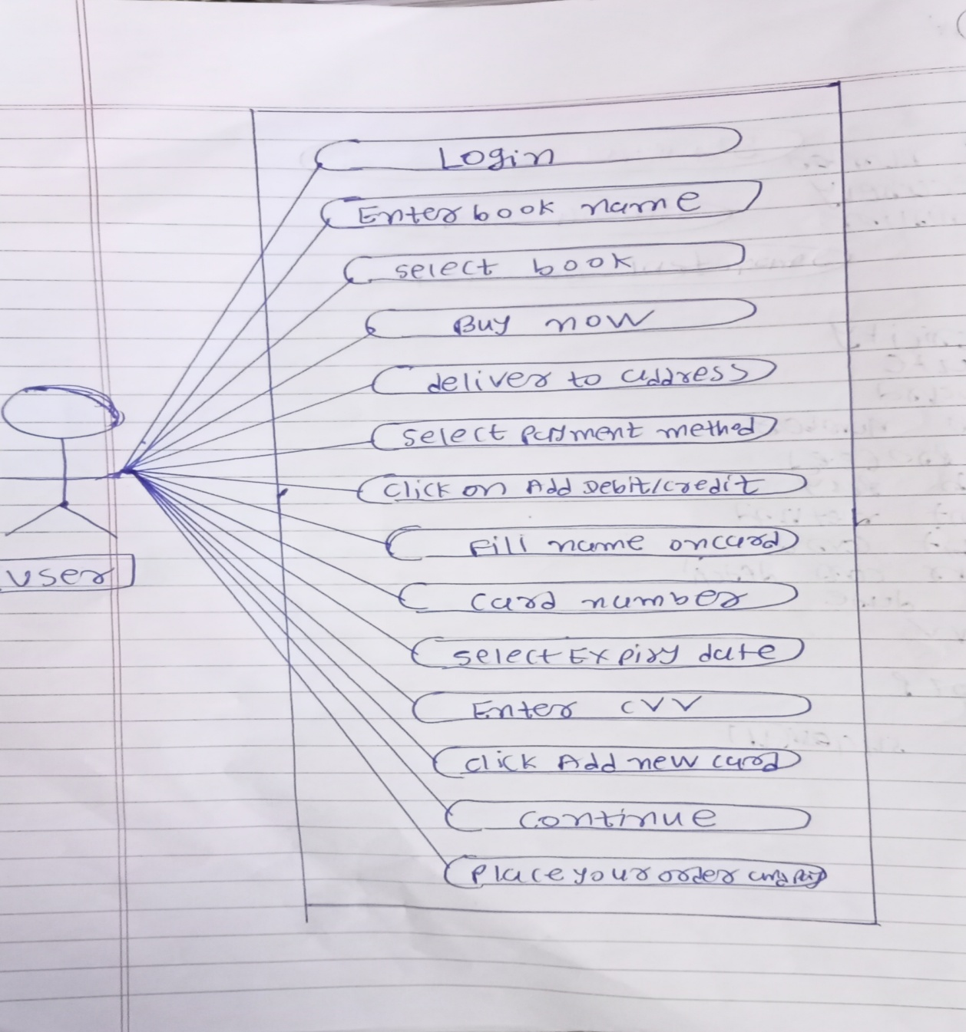

13. Draw usecase on online bill payment system (paytm)

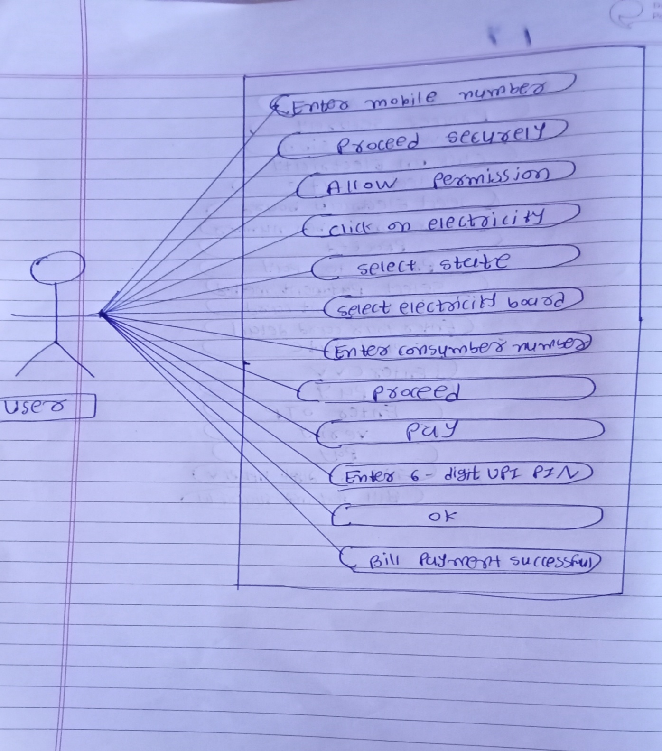

14. Write SDLC phases with basic introduction

(a) Requirement

- It is first phase of SDLC in which all the necessary information is collected from the customer to develop software as per their expectation

(b) Analysis

- Software developer will analysis about software

- How soon will is happen, how will it happen

(C) Design

- In the design phase, SRS document is created which contain all logical detail.

- Like how software will look like, which language will be used.

(D) Implementation

- When the designing of the software is completed , then developer starts coding using programming language.

(E) Testing

- Once the software development is completed, then testing team starts testing the functionality of entire system.

(F) Maintenance

- Maintenance is used for solve bug or error in software

15. Explain phases of the waterfall model

- In this model it will be used project where customer requirements must be frozen it means customer must be sure about which type of requirements need in his or her project

- This is sequential step by step model it means one phase is complete processed then after we will come second phase because we cannot go back that phase

Requirement

Analysis

Design

Implementation

Testing

Maintenance

(A) Requirement

- Requirement is first phase of waterfall model

- In this phase business analyst will communicate with customer about project like as project budget, project duration, which type of project

(B) Analysis

- In this phase business analyst will analyse what thing will be required regarding the project

- All the requirements will written in SRS document

(C) Design

- In this phase will be design regarding project

- DFD, Flowchart, LLD, HLD

(D) Implementation

- In this phase using programming language coding will be done

- like as c, c++, python, java

(E) Testing

- In this phase the project will be tested

- Whether project works properly or not according to customer requirement

- In this phase if found any bug in project while testing so project will be completed using bug because we cannot go back any phase

(F) Maintenance

- Customer will check all requirements are fulfilled or not

- If found any bug in project so maintenance phase will be solve that bug

16. Write phases of spiral model

Planning Risk analysis

Determination of objectives, Analysis of alternatives and Alternatives and constraints resolution of risks

Go, no-go decision

Customer evaluation Engineering

Assessment of the results Development of the

Of engineering “next level” product

Evolving system

1. Planning

* Requirements are gathered from the client regarding project.

1. Risk analysis

* risk analysis will check the requirement and decide risk form requirement
* if found any risk in requirement so risk analysis will send to requirement in planning
* if requirement is correct then will go first prototype

1. Engineering

- Then after requirement will come in engineering

- In engineering developer will do coding and tester will check the requirement

1. Customer Evaluation

* Requirement will come in customer evaluation from engineering
* Customer check the requirement whether correct or not
* if customer is not satisfied so that requirements will send in engineering and
* if customer is satisfied the requirements will send in planning.

17. Write agile manifesto principles

- Individual and interactions over process and tools

- Working software over comprehensive documentation

- Customer collaboration over contact negotiation

- Responding to change over following a plan

18. Explain Working methodology of agile model and also write pros and cons

- Agile model is a combination of iterative and incremental process models

- Agile methods break the product into small incremental builds.

- In agile while one part of project has been prepared then will doing release to market

=> Agile manifesto

1. Individual interactions

- Task with individual and all with interaction individually.

2. Working software

- Software should be work according to customer requirement.

3. Customer collaboration

- Customer will always negotiate during project.

4. Responding to change

- Quickly changes in project.

=>Pros

- Anytime changes are acceptable

- Suitable for changing requirements.

- Resource requirement are minimum.

=>Cons

- Depends on customer interaction, so if customer is not clear, team can be driven in the wrong direction.

- Not suitable for handling complex depencies.

19. Draw usecase on online shopping product using COD

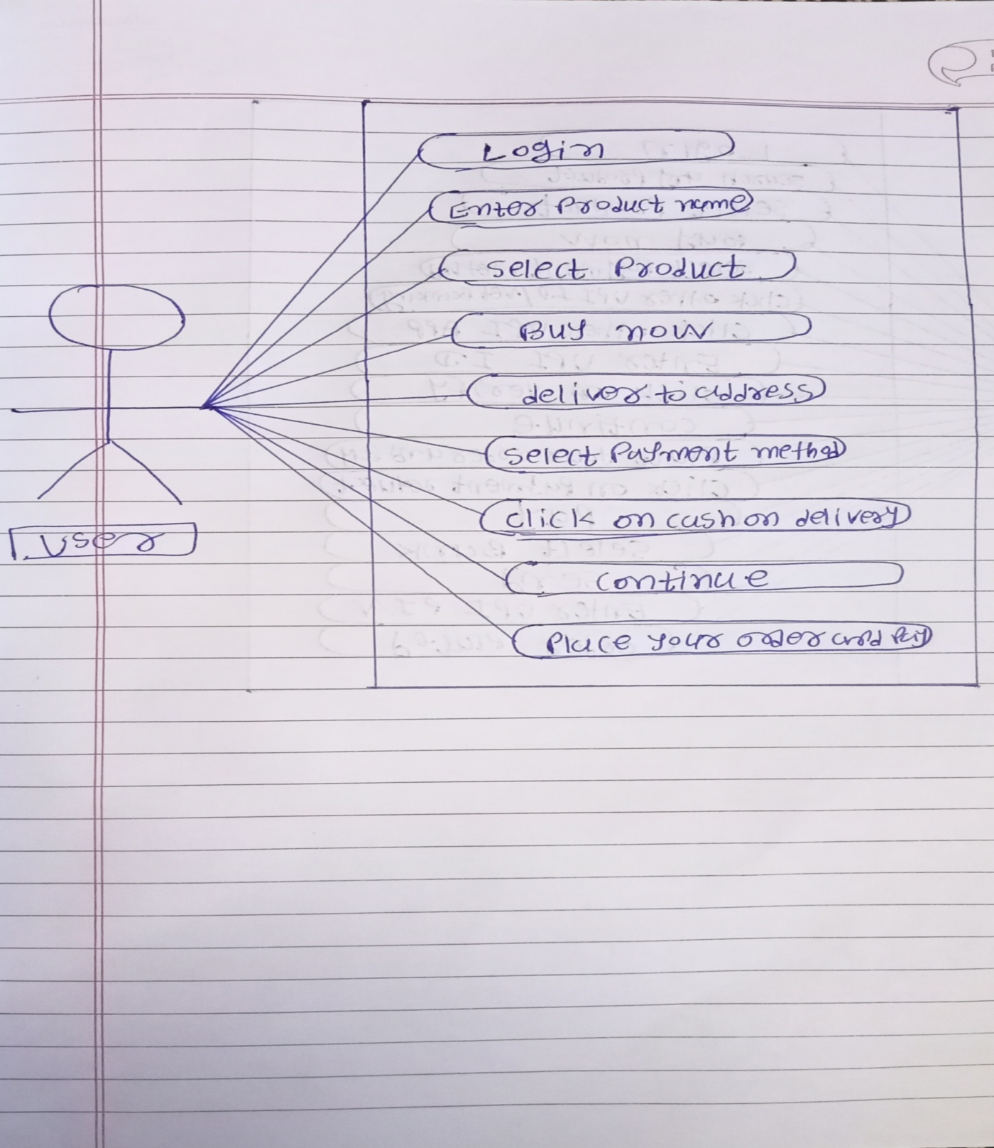

20. Draw usecase on online shopping product using payment gateway

